CALL FOR ABSTRACT
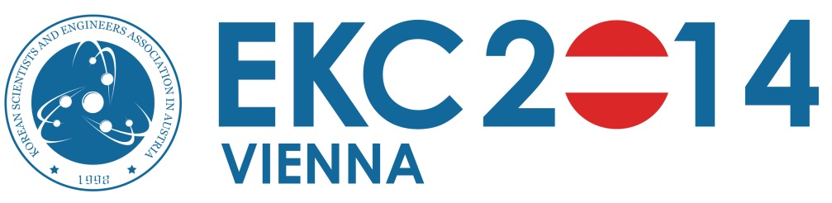
www.ekc2014.org
On behalf of EU-Korea conference on Science and Technology, the Program Committee is pleased to open its call for abstract submission to the EKC2014, July 24-25, 2014 to be held in Vienna, Austria. EKC2014 aims at providing a high level international forum between Europe and Korea by discussing recent advances in diverse areas of science and technology.
EKC2014 consists of poster sessions, oral presentation sessions and networking events. The poster session which covers all scientific areas will provide presenters with an opportunity to share their research ideas and interests with all delegates. The oral presentations host diverse topics in basic and applied sciences, particularly focusing on interdisciplinary topics or focal issues of these days. EKC2014 also provides opportunities to have broad networking among public and private organisations as well as the scientists and engineers in Europe and Korea. Please refer to the programme on the EKC2014 webpage for further detail information.
Traditionally EKC calls for abstracts for poster presentation only. Authors who would like to contribute to the poster session should submit abstracts through the EKC2014 webpage. Some authors who submitted abstracts may be requested to present in the oral presentation sessions by the Programme Committee. The official language of the EKC2014 is English and abstracts should be written in English with 300-500 words.

Important Information:
- Download the abstract template on http://ekc2014.org/
- Opening of Abstract submission: April 1, 2014
- All submission are done electronically at http://ekc2014.org/
- Deadline of Abstract submission: May 5, 2014
- Author notification: May 20, 2014

For more information, please visit the EKC2014 webpage (www.ekc2014.org). Any questions or requests can be sent to the secretariat of the programme committee (paper@ekc2014.org).

